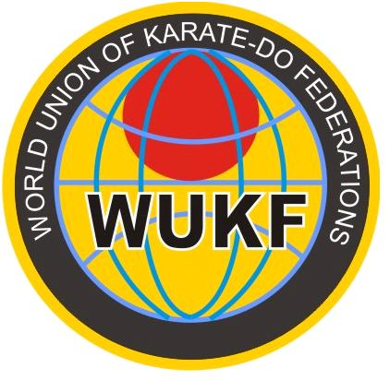
The World Union of Karate-do Organizations was originally founded in 1970. The name of "WUKO" was abandoned in the early 1990"s when WUKO and the International Traditional Karate Federation (ITKF) were to amalgamate as the World Karate Federation (WKF). The unification did not occur and the WKF was essentially the former WUKO group.
The existing international karate organizations are either pure style federations or multi-style groups which accept only one federation per country. Therefore many federations and associations are left outside of the international karate world.
The World Karate Confederation (WKC) was founded by a small group of karate enthusiasts on 4th May 1996 in Frankfurt/M, Germany.
Originally the WKC offered an important option for such groups in which all the different styles and federations can join a World body and fraternity, without having to compromise their style or size. In order that there are opportunities for all, the WKC accepted more than one federation or association per country.
"The purpose of WKC is to regulate, spread and foster Karate in the world from an educational, cultural and sports point of view by promoting Karate ethics, technical seminars, championships and all that is necessary to encourage the spreading of Karate-Do all over the world and to promote friendly and beneficial relations between its members." (WKC Statutes, Article 1.4)
The WKC grew from strength to strength. More than 1500 karate-ka from around the world attended the Junior World Championships and Children"s World Cup in Germany in October 2004.
Sadly, a small fraction of the WKC attempted to hijack the organization in April 2005. They held an illegal election and, in their eyes, replaced the legal executive committee. This resulted in the WKC separating into two factions.
At the 5th WKC World Karate Championships, in Fortaleza, Brazil in June 2005, the legal and rightful WKC voted to change provisory their name to the World Union of Karate-do Organizations (WUKO), and fight for WKC name into justice. This name was imposed by Mr. Carlo Henke that guaranteed to all the participants that is free and the use of it will cause no harm to the organization.
The new organization functioned more than 3.5 years, more than 150 federation requested affiliation being interested by good competitions, friendship with all the participants into a sport climate and not by the name of the organization.
Based on modern way of competition organization, a flexible management focused on the request of the affiliated members, with a continuous improvement system that
allows corrections depending of the specifics of the competitors in geographical region, of religion or material conditions, the Executive Committee elected in Fortaleza gave a proof of professionalism, more and more federations joining the organization.
Unfortunately the Executive Committee discovered that the Honorary President and founder member, Mr. Carlo Henke registered the WUKO mark in his name and not in the name of the organization of more than 150 members. Also he pressed the Executive Members to stop the process with the other fraction WKC and continue with the actual name.
At the Congress in Lido di Jesolo, WUKO President asked him in front of the participants to transfer WUKO mark and the mortgage in his own name of 34.000 Euros to the organization, but Mr. Henke refused it promising a discussion at the next elective Congress in June 2009, at Odessa, Ukraine.
Mr. Henke refused it arguing that the actual Executive Committee wants to change the name of the organization, choosing a new name free of any attacks from other organizations.
In 14th November 2008 Mr. Carlo Henke founded secretly a new entity, a "NEW WUKO" in Verbania - Italy, using "his property of name and mark", he "elect" himself as PRESIDENT,GENERAL COORDINATOR , CHAIRMAN and of course OWNER of this NEW WUKO.
On 30th of November 2008 President Osvaldo Messias de Oliveira received a letter from the Trade Mark Office forbidding the use of WUKO mark and logo to all the affiliated members starting from 2nd of December.
Mr. Carlo Henke made a new WUKO web page, copied the list Affiliated Members from our webpage, "elect" himself as new president and start to send letters to all the affiliated members asking new affiliation to "his NEW WUKO".
This crisis situation determined the members of Executive Committee to meet urgently and changed the name WUKO in WUKF - World Union of Karate-Do Federation, a measure to continue the legal run of organization till the Congress in Odessa.
In June 2009, at the programmed Congress the affiliated members will discuss and take democratically all the necessary decisions for the good working of the organization. The name is new but the organization is the same, all the affiliated members of the former WUKO sent letters of support (except FESIK), all the WUKF events will be organized like they were programmed before, the life of the organization will go on.
The former WUKO was founded in Rome on the 1st May 2005 by the Federations from Romania, Brazil, Portugal, Italy, Belgium and Spain, all these federations excepting FESIK from Italy continue now in WUKF.

